

Can the tag line be revised? Not to be so direct.

Selling point:

1. Up to 7 years tenure.

Enjoy repayment up to 7 years tenure

**Feature & Benefit**

1. Bai’ Al- Inah concept

Maybe can be simplified eg: as per mentioned in PDS.

**Requirement**



Eligibility

1. “Over 18”? Perhaps can be revised or
2. Age: 18 years to 65 years
3. Minimum loan is RM1, 000 with maximum RM100,000 (*This should be under loan features*)
4. Please include the eligibilities same as what is mentioned in the PF leaflet.

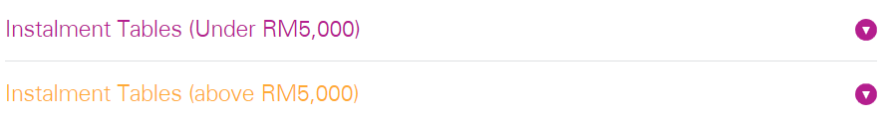

Suggestions:

* 1. **Instalment table for below 5K**
  2. **Instalment table for 5K and above**

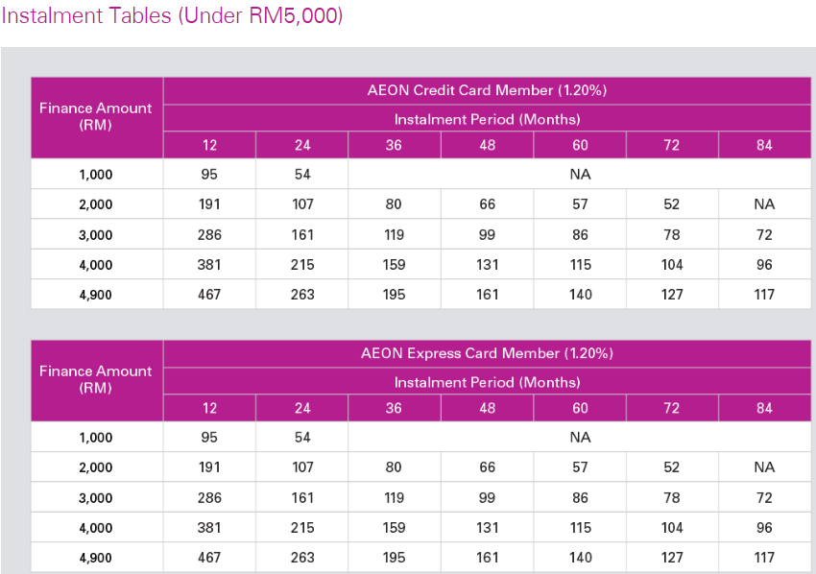

The above 2 tables can be merge. It is the same interest rate & instalment amount.

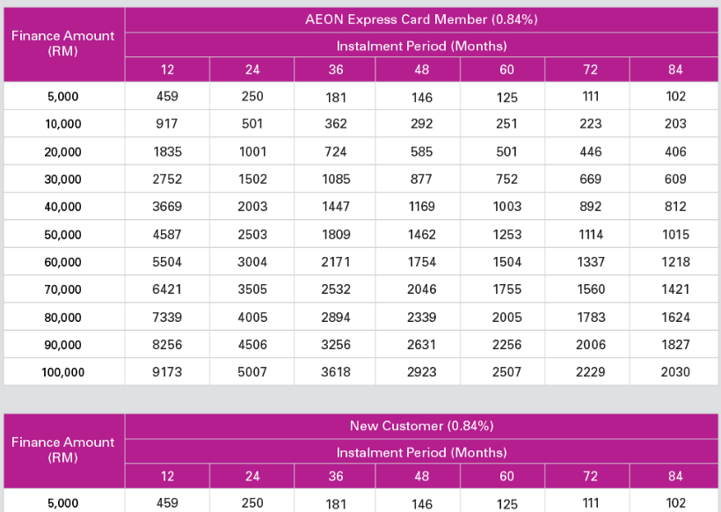

The above 2 tables can be merge. It is the same interest rate & instalment amount.

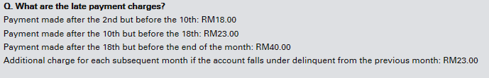

How if payment made on the 10th? Please replicate the contents below:-

|  |  |  |  |  |  |  |  |  |  |  |
| --- | --- | --- | --- | --- | --- | --- | --- | --- | --- | --- |
| |  | | --- | | Payment due is made after the due date up to the 10th of the month. | | |  |  | | --- | --- | |  | Payment due is made between the 11th and 18th of the month | | |  |  | | --- | --- | |  | Payment due is made on 19th onwards up to the month end closing. | | |  |  | | --- | --- | |  | Additional charge for each subsequent month if the account falls under delinquent from the previous month | |
| RM18.00 | RM23.00 | RM40.00 | RM23.00 |



Q & A , has grammar error.